Lab Assignment 8

0

1

2

3

4

who man woman woman woman

man

adult_male deck embark_town alive True NaN

False False False True

C

NaN

C

NaN

Southampton Cherbourg Southampton Southampton Southampton

no yes yes yes no

alone False False True False True

Aim : 1. Use the inbuilt dataset 'titanic'. The dataset contains 891 rows and contains information

about the passengers who boarded the unfortunate Titanic ship. Use the Seaborn library to

see if we can find any patterns in the data.

2. Write a code to check how the price of the ticket (column name: 'fare') for each passenger

is distributed by plotting a histogram

import pandas as pd import numpy as np

import matplotlib.pyplot as plt import seaborn as sns

import warnings warnings.filterwarnings('ignore')

dataset = sns.load_dataset('titanic') dataset.head()

|  |  |  |  |  |  |  |
| --- | --- | --- | --- | --- | --- | --- |
| survived pclass | sex | age | sibsp | parch | fare | embarked |
| class \ |  |  |  |  |  |  |
| 0 0 3 | male | 22.0 | 1 | 0 | 7.2500 | S |
| Third |  |  |  |  |  |  |
| 1 1 1 | female | 38.0 | 1 | 0 | 71.2833 | C |
| First |  |  |  |  |  |  |
| 2 1 3 | female | 26.0 | 0 | 0 | 7.9250 | S |
| Third |  |  |  |  |  |  |
| 3 1 1 | female | 35.0 | 1 | 0 | 53.1000 | S |
| First |  |  |  |  |  |  |
| 4 0 3  Third | male | 35.0 | 0 | 0 | 8.0500 | S |

sns.displot(x = dataset['age'],bins = 10)

C:\Users\CNLAB10\anaconda3\Lib\site-packages\seaborn\_oldcore.py:1119: FutureWarning: use_inf_as_na option is deprecated and will be removed in a future version. Convert inf values to NaN before operating instead.

with pd.option_context('mode.use_inf_as_na', True):

<seaborn.axisgrid.FacetGrid at 0x1bb0893a350>

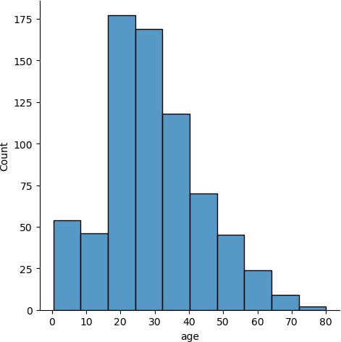

sns.displot(x = dataset['age'],bins = 10,kde=False)

C:\Users\CNLAB10\anaconda3\Lib\site-packages\seaborn\_oldcore.py:1119: FutureWarning: use_inf_as_na option is deprecated and will be removed in a future version. Convert inf values to NaN before operating instead.

with pd.option_context('mode.use_inf_as_na', True):

<seaborn.axisgrid.FacetGrid at 0x1bb0c09f7d0>



sns.jointplot(x = dataset['age'], y =dataset['fare'],kind = 'scatter')

C:\Users\CNLAB10\anaconda3\Lib\site-packages\seaborn\_oldcore.py:1119: FutureWarning: use_inf_as_na option is deprecated and will be removed in a future version. Convert inf values to NaN before operating instead.

with pd.option_context('mode.use_inf_as_na', True): C:\Users\CNLAB10\anaconda3\Lib\site-packages\seaborn\_oldcore.py:1119: FutureWarning: use_inf_as_na option is deprecated and will be removed in a future version. Convert inf values to NaN before operating instead.

with pd.option_context('mode.use_inf_as_na', True):

<seaborn.axisgrid.JointGrid at 0x1bb0c88f490>

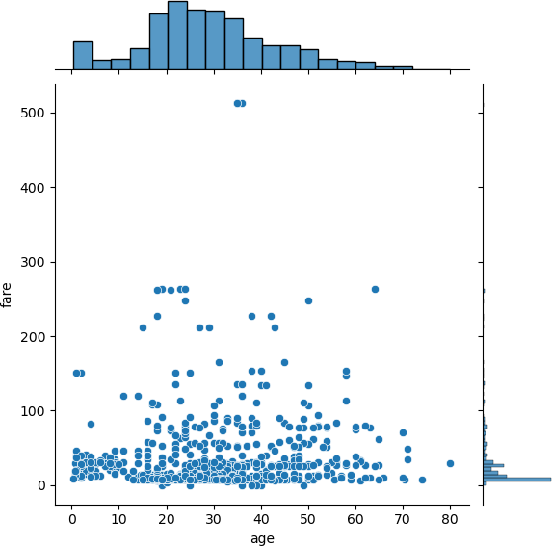

sns.jointplot(x = dataset['age'], y =dataset['fare'],kind = 'hex')

C:\Users\CNLAB10\anaconda3\Lib\site-packages\seaborn\_oldcore.py:1119: FutureWarning: use_inf_as_na option is deprecated and will be removed in a future version. Convert inf values to NaN before operating instead.

with pd.option_context('mode.use_inf_as_na', True): C:\Users\CNLAB10\anaconda3\Lib\site-packages\seaborn\_oldcore.py:1119: FutureWarning: use_inf_as_na option is deprecated and will be removed in a future version. Convert inf values to NaN before operating instead.

with pd.option_context('mode.use_inf_as_na', True):

<seaborn.axisgrid.JointGrid at 0x1bb0cb8b190>

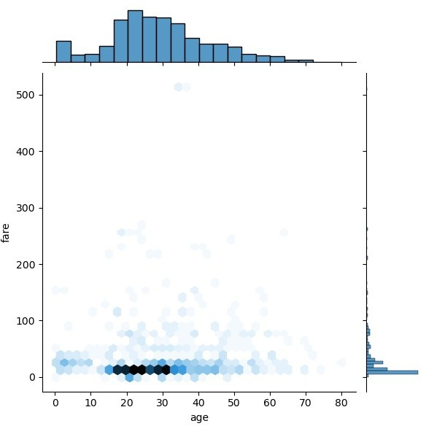

sns.rugplot(dataset['fare'])

C:\Users\CNLAB10\anaconda3\Lib\site-packages\seaborn\_oldcore.py:1119: FutureWarning: use_inf_as_na option is deprecated and will be removed in a future version. Convert inf values to NaN before operating instead.

with pd.option_context('mode.use_inf_as_na', True):

<Axes: xlabel='fare'>

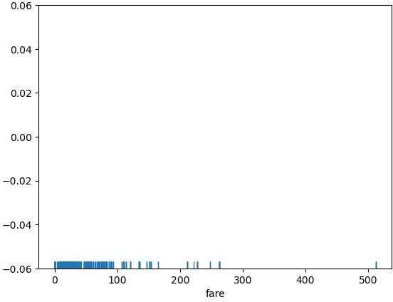

sns.barplot(x='sex' , y= 'age', data=dataset)

<Axes: xlabel='sex', ylabel='age'>

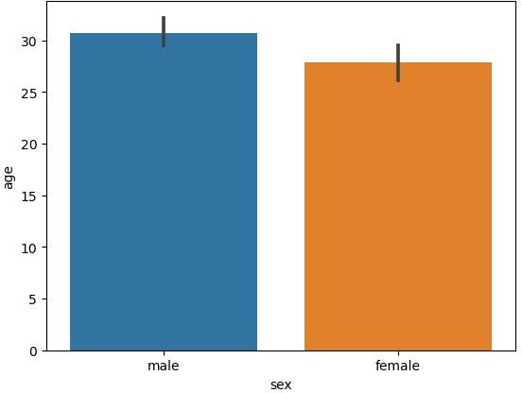

sns.barplot(x='sex' , y= 'age', data=dataset , estimator=np.std)

C:\Users\CNLAB10\anaconda3\Lib\site-packages\numpy\lib\ nanfunctions.py:1384: RuntimeWarning: All-NaN slice encountered

return _nanquantile_unchecked(

<Axes: xlabel='sex', ylabel='age'>

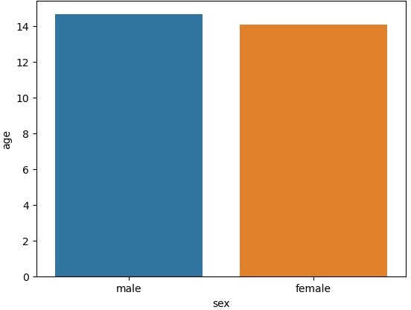

sns.countplot(x='sex' , data=dataset)

<Axes: xlabel='sex', ylabel='count'>

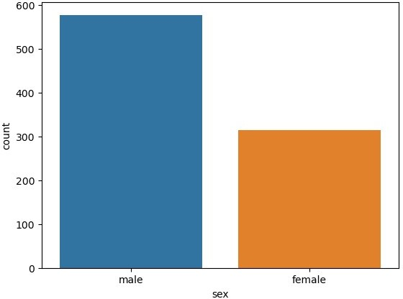

sns.countplot(x='sex' , data=dataset)

<Axes: xlabel='sex', ylabel='count'>



sns.boxplot(x='sex' ,y='age' ,data=dataset)

<Axes: xlabel='sex', ylabel='age'>

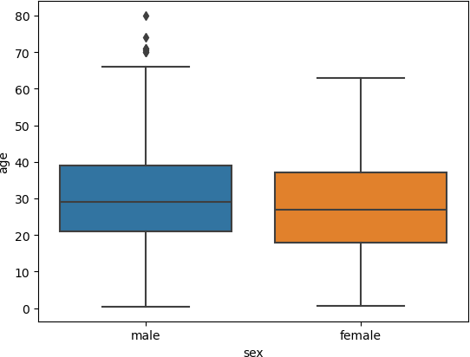

sns.boxplot(x='sex' ,y='age' ,data=dataset, hue="survived")

<Axes: xlabel='sex', ylabel='age'>

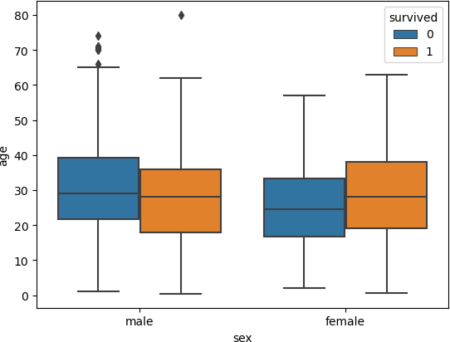

sns.violinplot(x='sex',y='age', data=dataset)

<Axes: xlabel='sex', ylabel='age'>

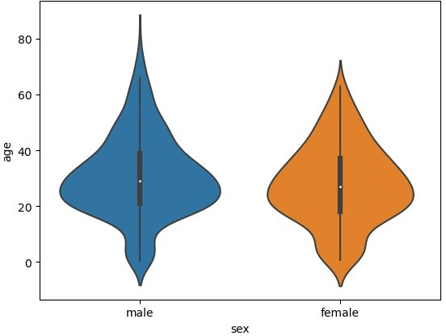

sns.violinplot(x='sex',y='age', data=dataset, hue ='survived')

<Axes: xlabel='sex', ylabel='age'>

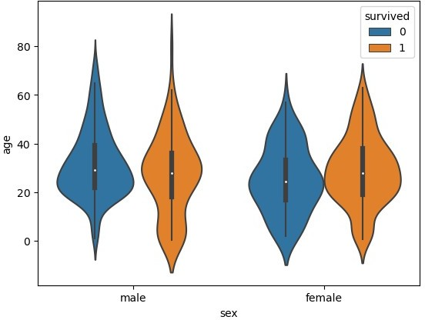

sns.stripplot(x='sex',y='age', data=dataset , jitter=False)

C:\Users\CNLAB10\anaconda3\Lib\site-packages\seaborn\_oldcore.py:1119: FutureWarning: use_inf_as_na option is deprecated and will be removed in a future version. Convert inf values to NaN before operating instead.

with pd.option_context('mode.use_inf_as_na', True): C:\Users\CNLAB10\anaconda3\Lib\site-packages\seaborn\_oldcore.py:1119: FutureWarning: use_inf_as_na option is deprecated and will be removed in a future version. Convert inf values to NaN before operating instead.

with pd.option_context('mode.use_inf_as_na', True):

<Axes: xlabel='sex', ylabel='age'>

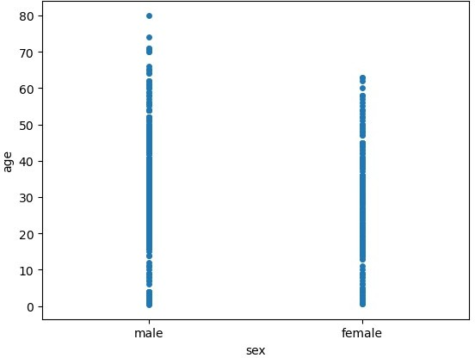

sns.stripplot(x='sex',y='age', data=dataset , jitter=True)

<Axes: xlabel='sex', ylabel='age'>

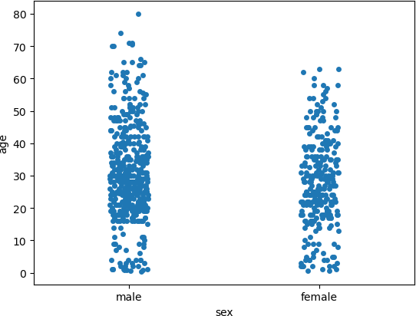

sns.swarmplot(x='sex', y='age', data=dataset)

<Axes: xlabel='sex', ylabel='age'>

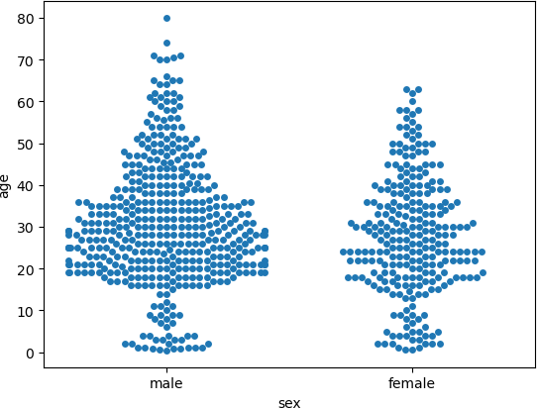

sns.swarmplot(x='sex', y='age', data=dataset , hue='survived')

<Axes: xlabel='sex', ylabel='age'>

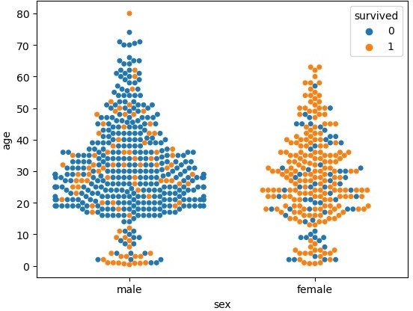

Name : Vaishnavi Jagtap Roll : 13229